**Lighting Control System**

**Hardware part:**

We use ESP32 microcontroller as it have 34 GPIO Pins but some pins have restrictions:

* GPIO34 to GPIO39 are input only pins
* GPIO6 to GPIO11 connected to the integrated SPI flash on the chip and are not recommended for other uses.

In conclusion we have 20 I/O pins and 4 Input only pins.

**Note:**  we have 3 verification LEDS.

So the maximum number of Lamps we can control are 10 Lamps in addition of 10 switches.

**PCB design :**

|  |  |
| --- | --- |
| Components | Number used |
| ESP32 | 1 |
| Rosetta | 21 |
| Relays : jkx-15F  Datasheet: <https://pdf.voron.ua/files/pdf/relay/power/JQX-15F(T90).pdf> | 10 |
| Transistors :BC547 | 10 |
| Leds for verification | 3 |
| Resistance 330 Ohm | 13 |
| Resistance 10K | 10 |
| Diodes | 10 |
| HiLink | 1 |

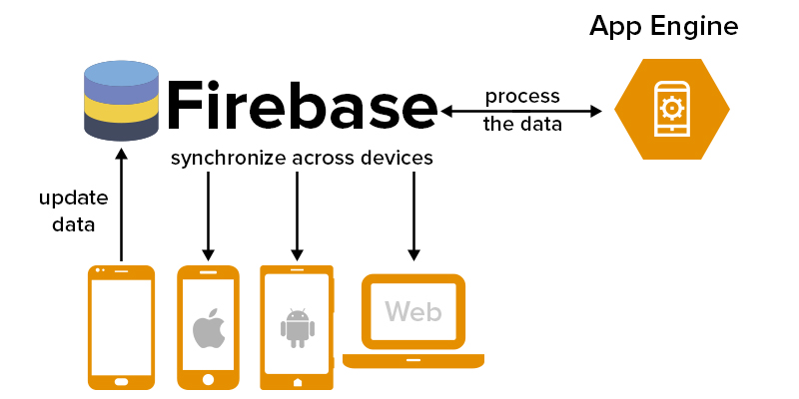What is Firebase?

Firebase Realtime Database

Store and sync data with our NoSQL cloud database. Data is synced across all clients in realtime, and remains available when your app goes offline.

The Firebase Realtime Database is a cloud-hosted database. Data is stored as JSON and synchronized in realtime to every connected client. When you build cross-platform apps with our iOS, Android, and JavaScript SDKs, all of your clients share one Realtime Database instance and automatically receive updates with the newest data.

Key features of Cloud Firestore include:

* Documents and collections with powerful querying
* iOS, Android, and Web SDKs with offline data access
* Real-time data synchronization
* Automatic, multi-region data replication with strong consistency
* Node, Python, Go, and Java server SDKs

Collaborate across devices with ease

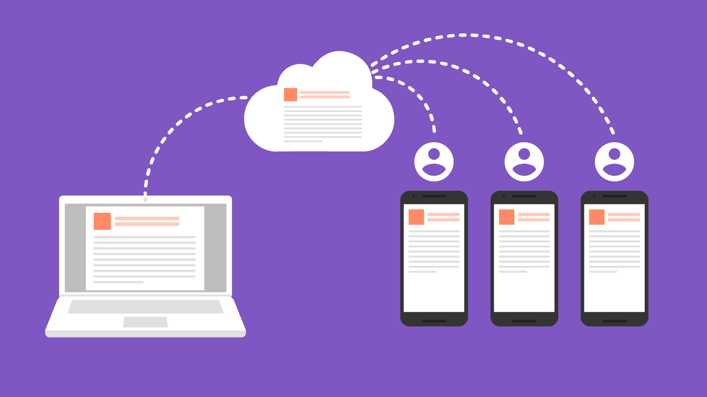Realtime syncing makes it easy for your users to access

their data from any device: web or mobile, and it helps

your users collaborate with one another.

Build serverless apps

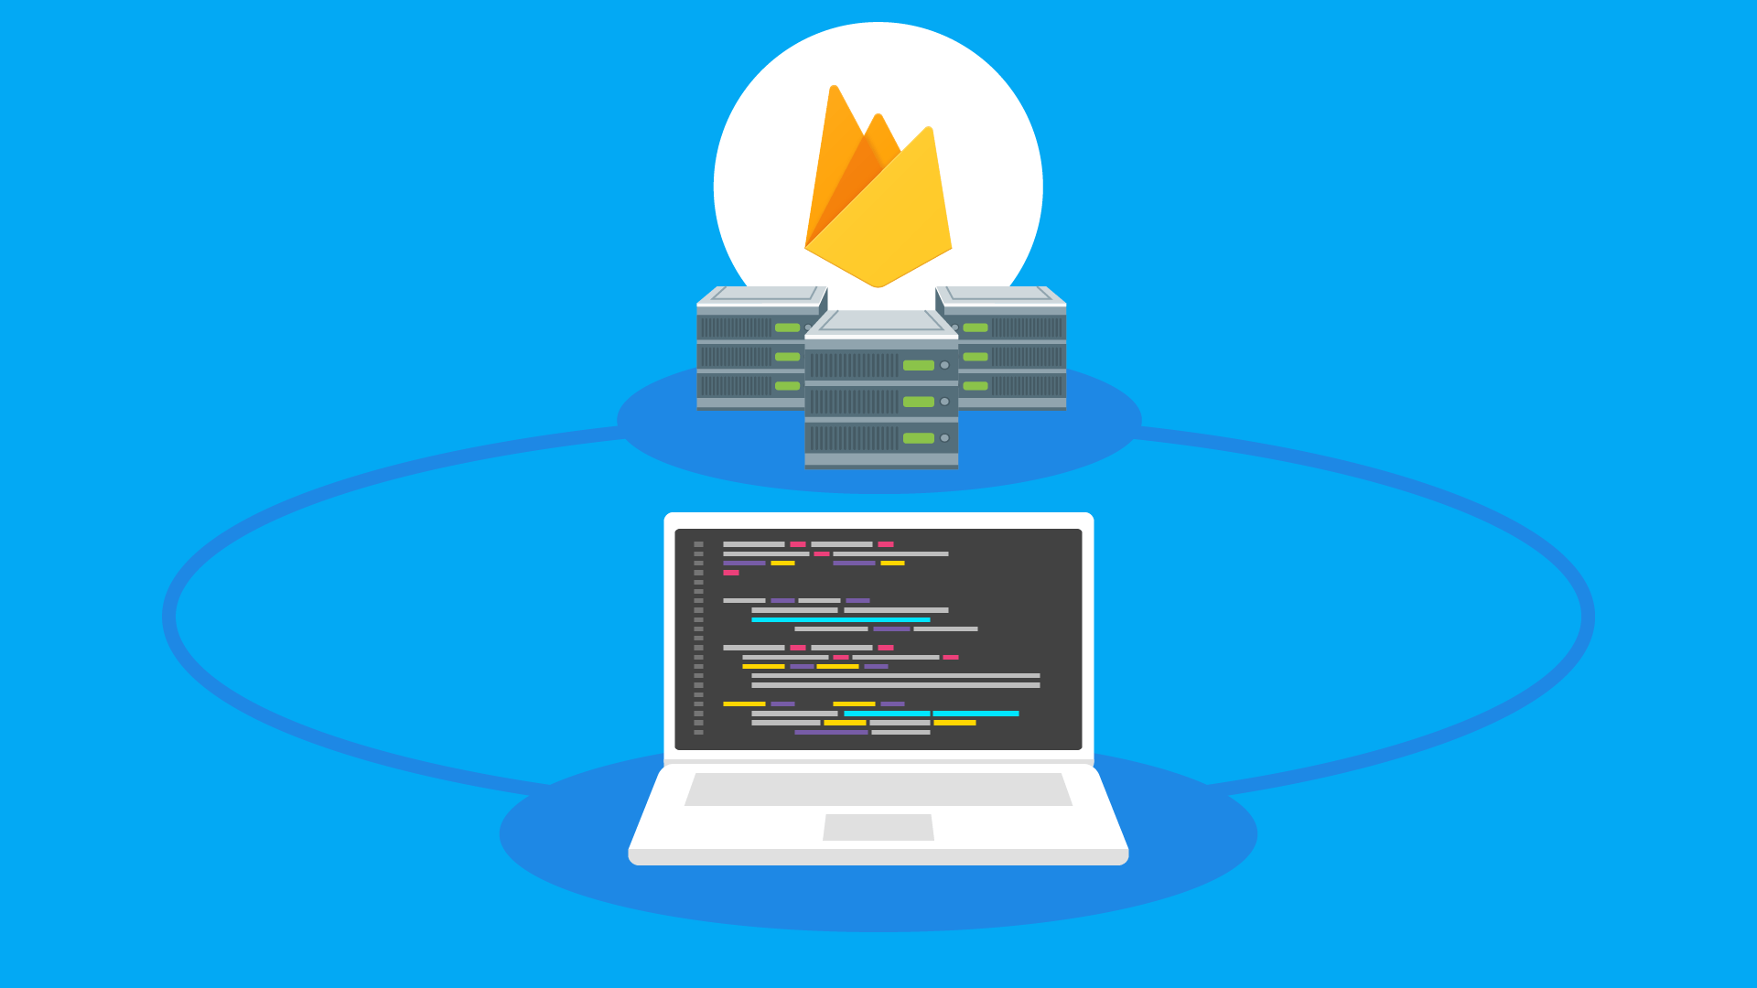Realtime Database ships with mobile and web SDKs

so you can build apps without the need of servers.

Optimized for offline use

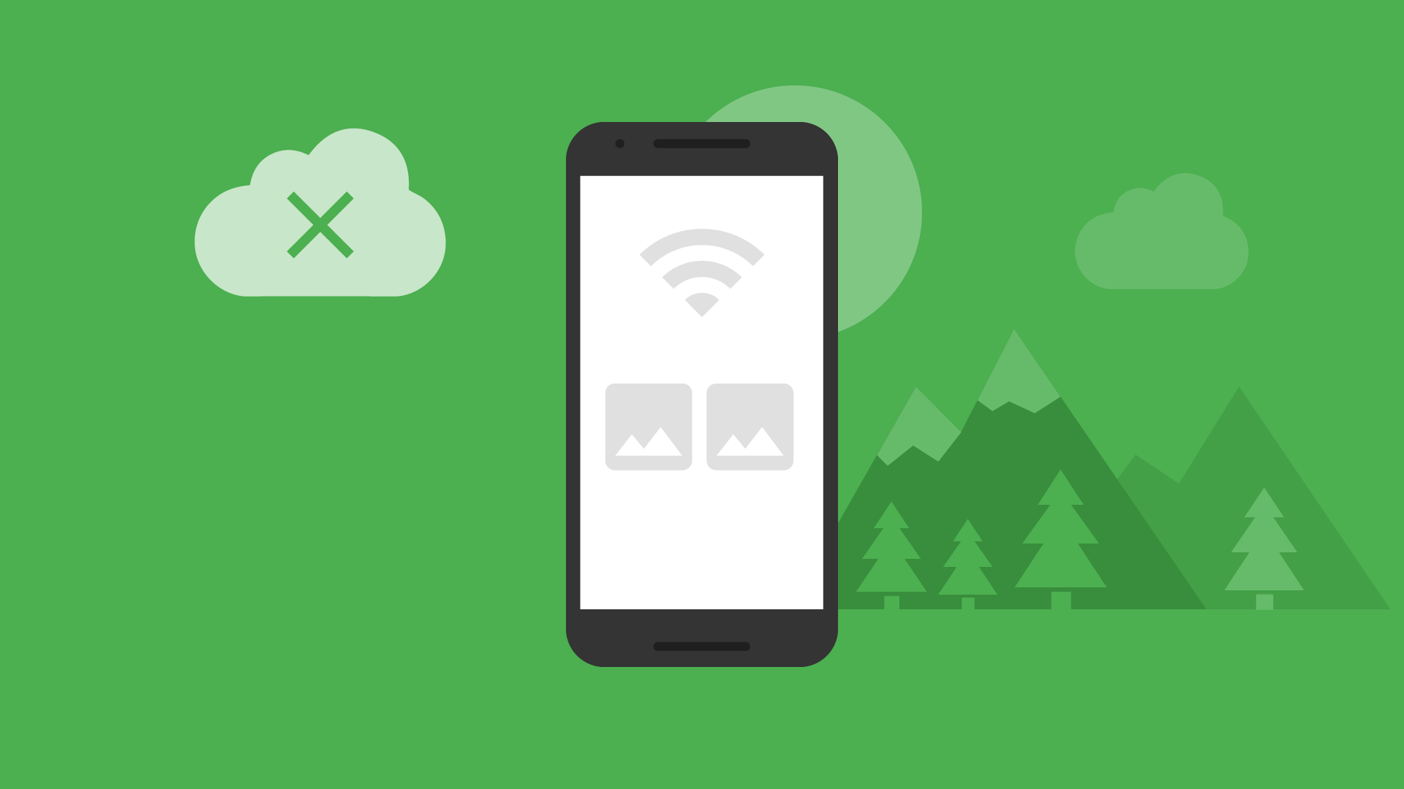When your users go offline, the Realtime Database SDKs

use local cache on the device to serve and store changes.

when the device comes online, the local data

is automatically synchronized.

Strong user-based security

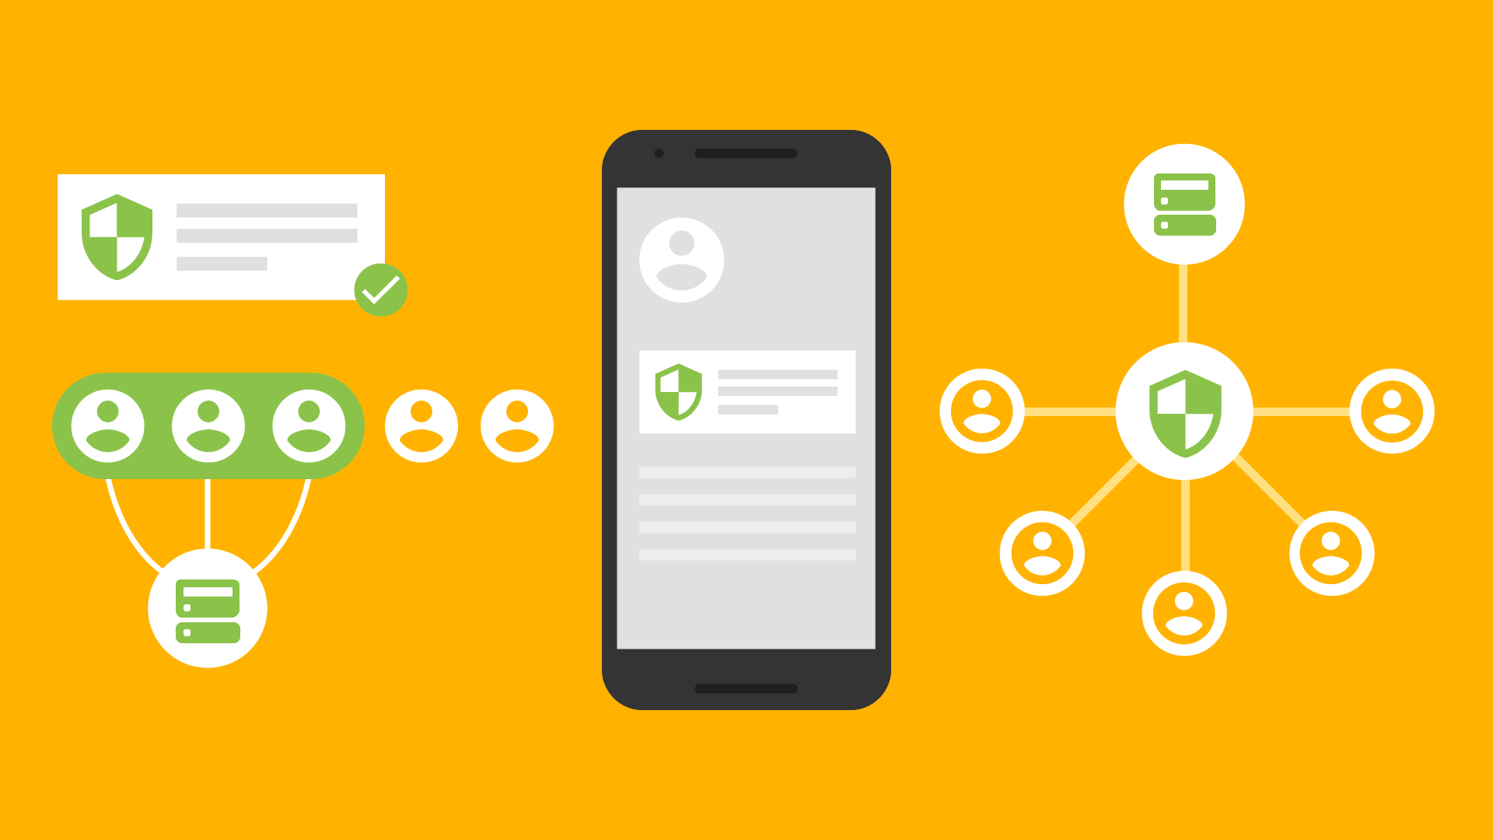The Realtime Database integrates with Firebase

authentication to provide simple and intuitive

authentication for developers. You can use our

declarative security model to allow access based

on user identity or with pattern matching on your data.